|  |  |  |  |
| --- | --- | --- | --- |
| **paf_kiet_logo** | **COLLEGE OF COMPUTING AND INFORMATION SCIENCE** | | |
| **Final Assessment Spring 2021 Semester** | | |
| **Class Id** | 106226-229,106337 | **Course Title** | Basic Electronics (B.E) |
| **Program** | BS(CS) | **Campus / Shift** | Main Campus / Morning |
| **Date** | 28th April 2021 | **Total points** | 80 |
| **Duration** | 03 hours | **Faculty Name** | Faisal Ahmed / Usman Saeed / Ali Babar |
| **Student Id** | 12113. | **Student Name** | Shahmeer khan. |

**Instructions:**

* Filling out Student-ID and Student-Name on exam header is mandatory.
* Do not remove or change any part of exam header or question paper.
* Write down your answers in given space or at the end of exam paper with proper title “Answer for Question# \_ \_”.
* Answers should be formatted correctly (font size, alignment and etc)
* Handwritten text or image should be on A4 size page with clear visibility of contents.
* Only PDF format is accepted (Student are advise to install necessary software)
* In case of CHEATING, COPIED material or any unfair means would result in negative marking or ZERO.
* A mandatory recorded viva session will be conducted to ascertain the quality of answer scripts where deemed necessary.

**Caution:** Duration to perform Final term Assessment is **03 hours only** and you all have to submit your answer script within 3 hours. **Therefore, if you failed to upload answer sheet on LMS (in PDF format) within 03 hours limit, you would be considered as ABSENT/FAILED.**

**Solve all questions in sequence as given.**

**Question 1-**

Solve by Method of Branch Current by using figure 1.

**(10 Points)**

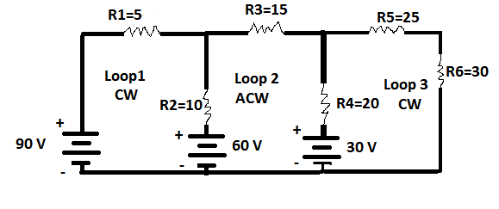

Figure 1

**Question 2-A**- For the circuit given below in figure 2, you are required to find and answer the following.

1. What is the importance of IC and VCE while targeting the Q-Point in BJT graph?
2. Determine the Q-Point for the circuit and also draw the DC Load Line. Assume βDC=120. Properly tag all the values on Q-Point graph. Show all steps of calculation. **(20 Points)**

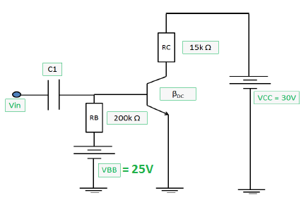

Figure 2

**Part B-** Explain why it is necessary to add capacitor in High Pass filter, draw circuit diagram and explain w.r.t combination of Capacitor and RL.

**Part C**- We have different Micro-controllers which can be operated through Transistors but the major discussion is only about Micro-controllers internal operations and input and output which will exclude powering it. What will be the proper choice from switching, amplification and regulation? Justify your answer.

**Question 3-** **(10 Points)**

**Part A-** Why negative peaks are eliminated in Half Wave Rectification and how this can be achieved in Full Wave Rectification without eliminating these peaks?

**Part B-** Is Bridge Full Wave Rectifier only working with Transformers or can we use it with AC source as well? If you are agree with this then provide any advantage of this rectifier circuit without using the transformers OR if you are disagree then provide justification of your answer.

**Question 4-** **(20 Points)**

Answer these questions.

1. Explain Phase inversion of Common Emitter Amplifier.
2. How Common Base Amplifier differs from Common Emitter and Common Collector Amplifier?
3. Calculate Voltage Gain if RC = 150 Ω and RL = 200 Ω, **IE = 1.5mA**

**Question 5- (10 Points)**

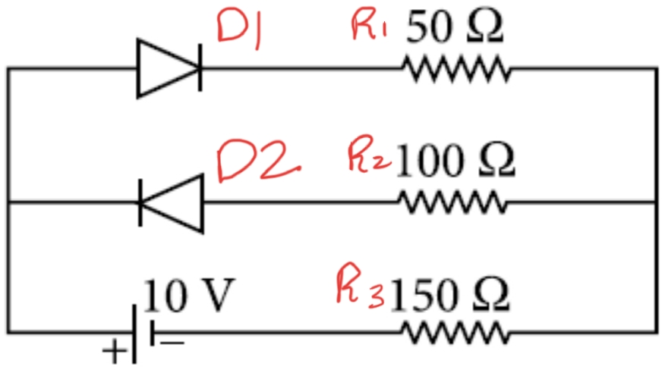For circuit given in Figure 3 use Complete Diode Model and find the voltage across R1 and R2 and total current flowing in this circuit. Given that diode forward resistance is 15 Ohms for D1 and 10 Ohms for D2, also reverse current flowing acrossD2 is 20 micro Amperes.

Figure 3

**Question 6-**

Draw AC and DC equivalent circuit for the circuit given in **Figure 4. (10 Points)**

**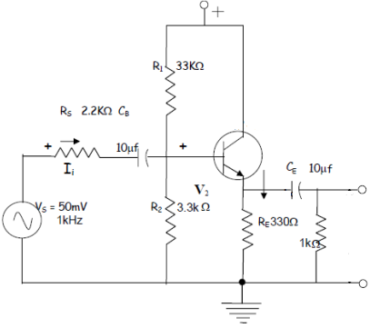**

Figure 4

**======XXXX==End of Exam==XXXX=====**